# Ideation Phase Define the problem statement

|  |  |
| --- | --- |
| Date | 22 October 2022 |
| Team ID | PNT2022TMID26524 |
| Project Name | Nutrition Assistant Application |
| Maximum Marks | 2Mark |

Problem statement:

Nutrition assistant application:

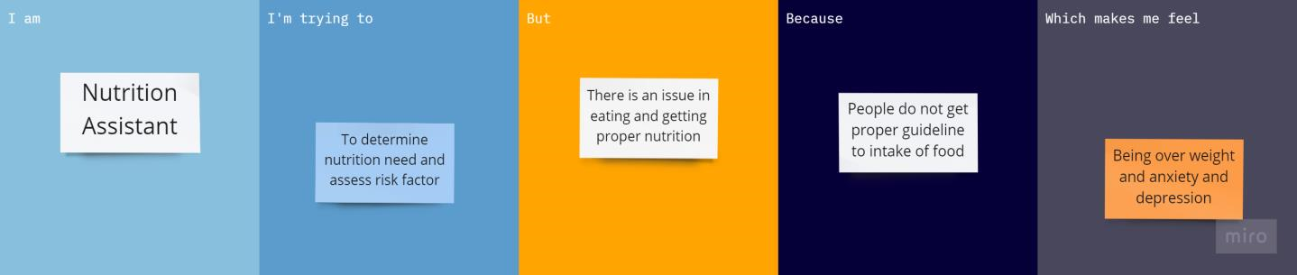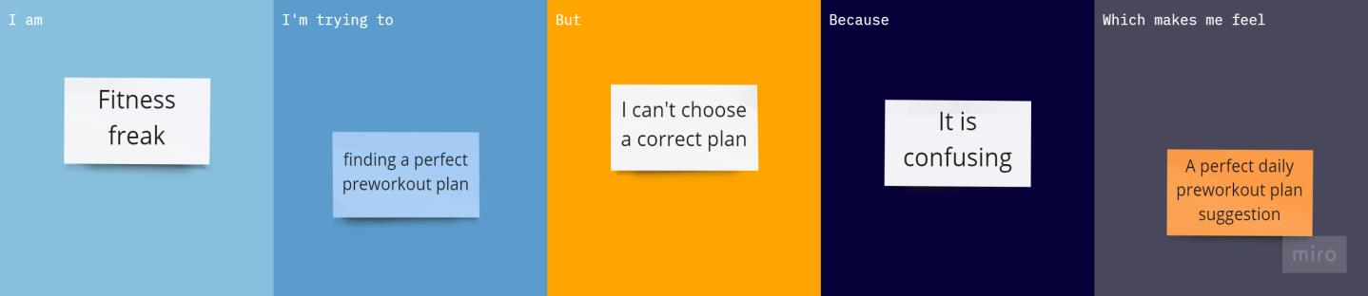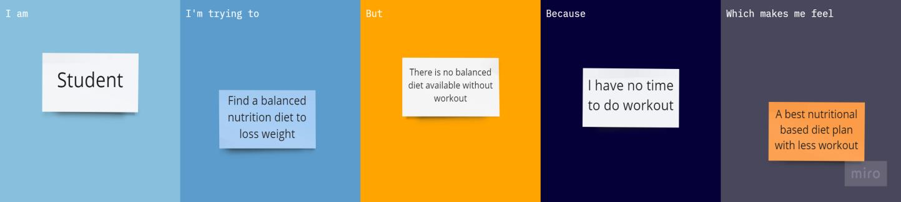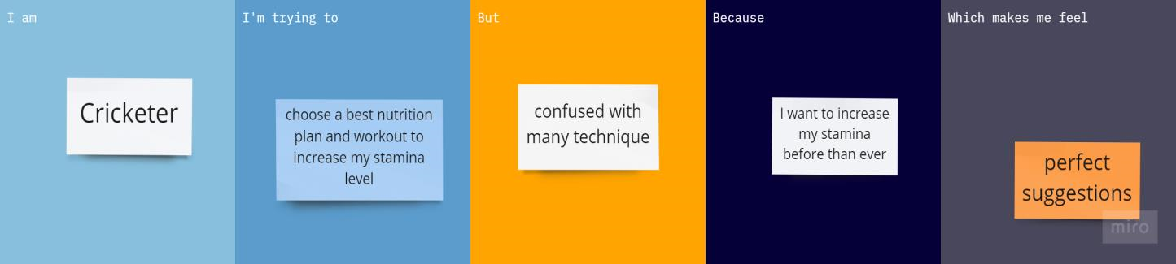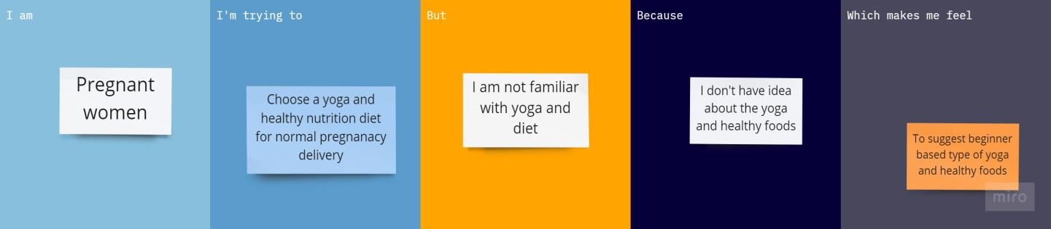

|  |  |  |  |  |  |
| --- | --- | --- | --- | --- | --- |
| **Problem**  **Statement**  **PS-1** | **I am**  **(customer)** | **I’m trying to** | **But** | **Because** | **Which make me feel** |
| PS-1 | Nutrition  Assistant | To determine nutrition need and assess risk factor | There is an issue in eating and getting proper nutrition | People do not get proper guideline to intake of food | Being over weight and anxiety and depression |
| PS-2 | Fitness freak | Findings a  perfect preworkout plan | I can’t choose a correct plan | It is  confusing | A perfect daily preworkout plan suggestion |
| PS-3 | Student | Find a balanced nutrition diet to loss weight | There is no balanced diet available without workout | I have no time to do workout | A best nutritional based diet plan with less workout |
| PS-4 | Cricketer | Choose a best nutrition plan and workout to increase my stamina level | confused with many technique | I want to increase my stamina level | Perfect suggestions |
| PS-5 | Pregnant women | Choose a yoga and healthy nutrition diet for normal pregnancy delivery | I am not familiar  with yoga and  diet | I don’t have idea about the yoga and healthy foods | To suggest beginner based type of yoga and healthy foods |